**Q1. Simulate a small network with switches and multiple devices. Use ping to generate traffic and observe the MAC address table of the switch. Capture packets using Wireshark to analyze Ethernet frames and MAC addressing.**

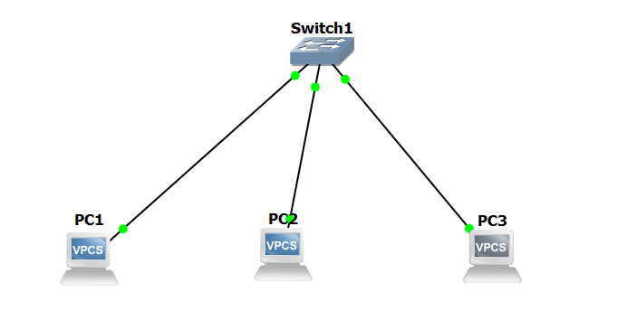

**Traffic Generation:**

**Pinging PC1🡪 PC3**

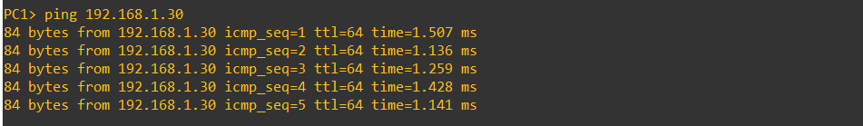

**Pinging PC2🡪PC3**

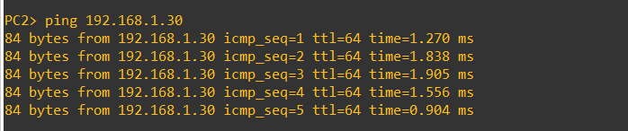

**Pinging PC3🡪PC1**

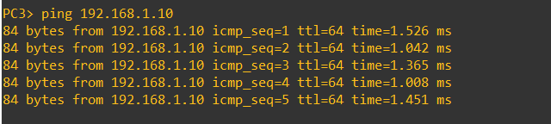

**Capturing Packets:**

